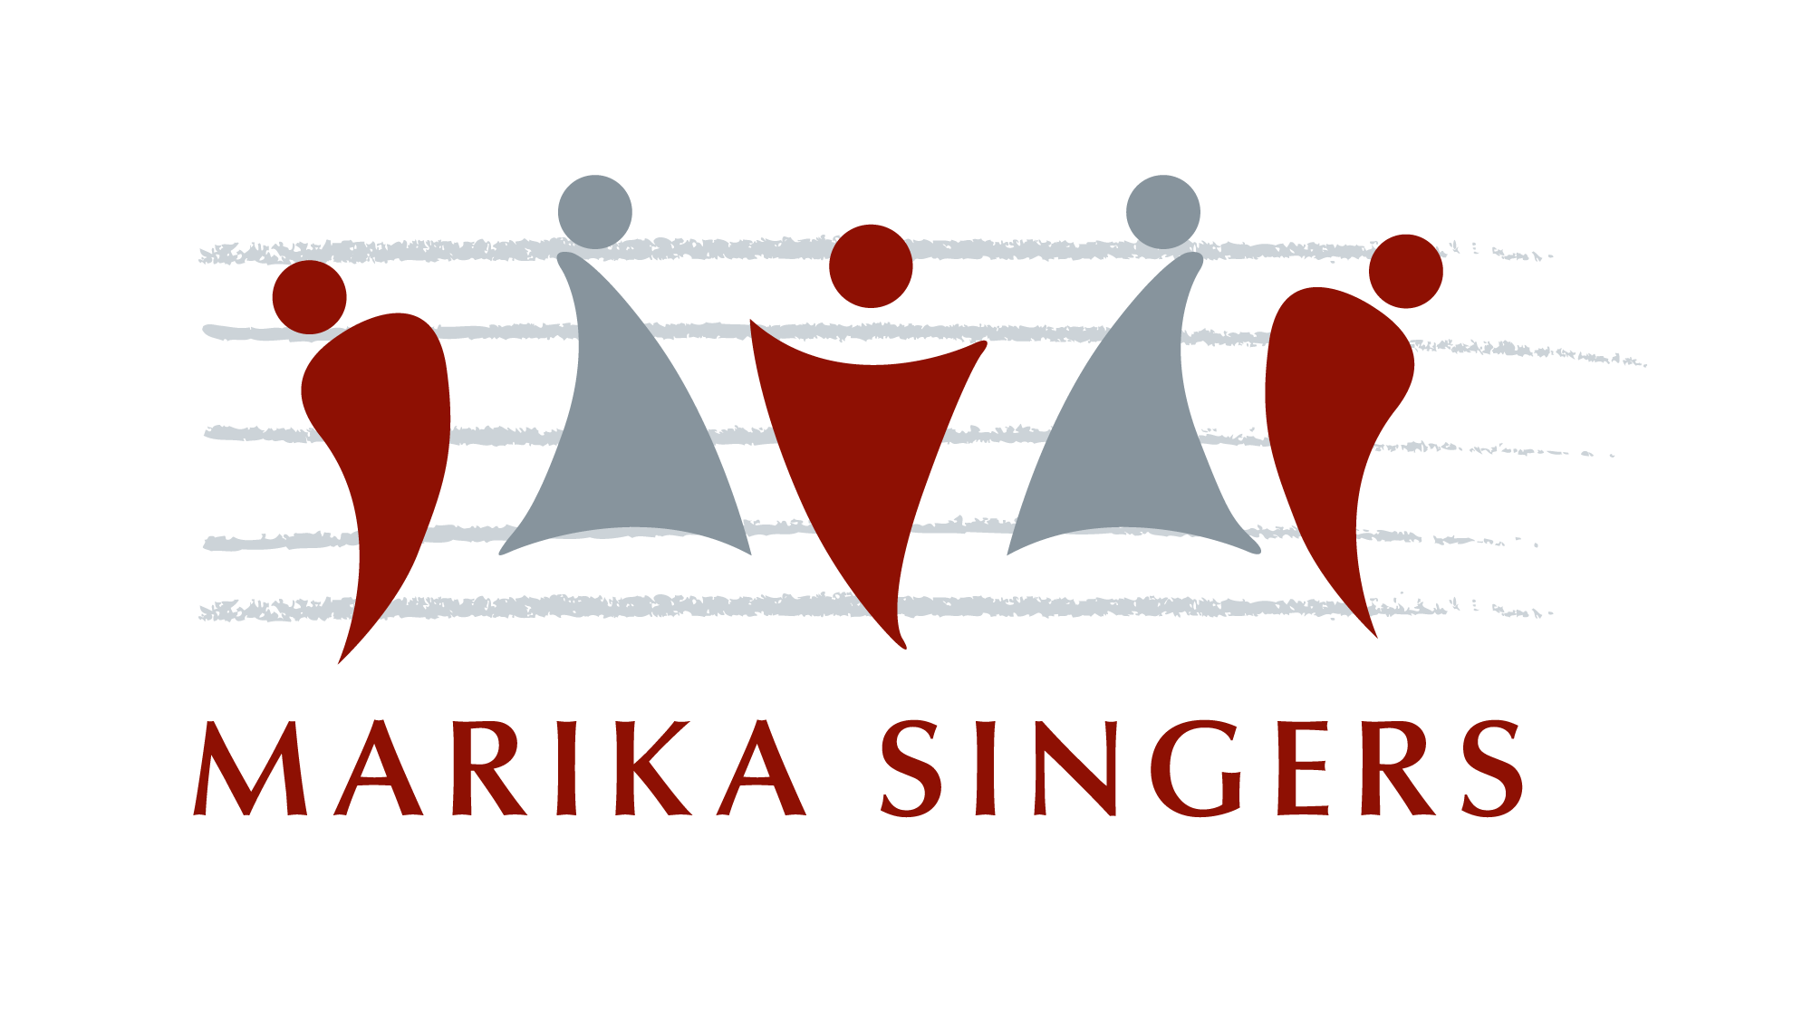

Roztoky, 26.6. 2021
hotel Academic, 18:00

Fredie Mercury: We Will Rock You
Metallica: Nothing Else Matters
Roger Waters: The Post War Dream
Bob Dylan: Knockin' on Heaven's Door
F. Andre / G. Osvaldová: Hvězdy jako hvězdy
R. P. Williams / G. A. Chambers: Angels
Martin Homola – sólová kytara
W. A. Mozart: Una donna a quindici anni
Michael Eugene Archer: Unshaken
Roger Watters: Comfortably Numb
J. Fogerty: Proud Mary
B. Gibb / R. Gibb: Emotion
Wayfaring Stranger
J. Harris / N. Jones: Don't Know Why
B. Knowles / A. Dent / M. Knowles: Survivor
M. Chapman / H. Knight: The Best
Ch. Berry: Roll Over Beethoven
Bob Marley: One Love
Man of Constant Sorrow
K. Tunstall: Black Horse And The Cherry Tree
Jon Bon Jovi: Bed of Roses
Prince Rogers Nelson: Purple Rain
Matthew Bellamy: Uprising
Reynolds / Sermon / McKee / Platzman:
I Bet My Life
Mark Brymer: Believer
OneRepublic: Love Runs Out

www.marikasingers.cz

Roztoky, 26.6. 2021
hotel Academic, 18:00

Fredie Mercury: We Will Rock You
Metallica: Nothing Else Matters
Roger Waters: The Post War Dream
Bob Dylan: Knockin' on Heaven's Door
F. Andre / G. Osvaldová: Hvězdy jako hvězdy
R. P. Williams / G. A. Chambers: Angels
Martin Homola – sólová kytara
W. A. Mozart: Una donna a quindici anni
Michael Eugene Archer: Unshaken
Roger Watters: Comfortably Numb
J. Fogerty: Proud Mary
B. Gibb / R. Gibb: Emotion
Wayfaring Stranger
J. Harris / N. Jones: Don't Know Why
B. Knowles / A. Dent / M. Knowles: Survivor
M. Chapman / H. Knight: The Best
Ch. Berry: Roll Over Beethoven
Bob Marley: One Love
Man of Constant Sorrow
K. Tunstall: Black Horse And The Cherry Tree
Jon Bon Jovi: Bed of Roses
Prince Rogers Nelson: Purple Rain
Matthew Bellamy: Uprising
Reynolds / Sermon / McKee / Platzman:
I Bet My Life
Mark Brymer: Believer
OneRepublic: Love Runs Out

www.marikasingers.cz

Roztoky, 26.6. 2021
hotel Academic, 18:00

Fredie Mercury: We Will Rock You
Metallica: Nothing Else Matters
Roger Waters: The Post War Dream
Bob Dylan: Knockin' on Heaven's Door
F. Andre / G. Osvaldová: Hvězdy jako hvězdy
R. P. Williams / G. A. Chambers: Angels
Martin Homola – sólová kytara
W. A. Mozart: Una donna a quindici anni
Michael Eugene Archer: Unshaken
Roger Watters: Comfortably Numb
J. Fogerty: Proud Mary
B. Gibb / R. Gibb: Emotion
Wayfaring Stranger
J. Harris / N. Jones: Don't Know Why
B. Knowles / A. Dent / M. Knowles: Survivor
M. Chapman / H. Knight: The Best
Ch. Berry: Roll Over Beethoven
Bob Marley: One Love
Man of Constant Sorrow
K. Tunstall: Black Horse And The Cherry Tree
Jon Bon Jovi: Bed of Roses
Prince Rogers Nelson: Purple Rain
Matthew Bellamy: Uprising
Reynolds / Sermon / McKee / Platzman:
I Bet My Life
Mark Brymer: Believer
OneRepublic: Love Runs Out

www.marikasingers.cz

